**Ola Taxi Scenarios**

The currency used to denote travel fare is INR (Indian National Rupee).

**There are four categories of taxis:**

* • Micro: Super small taxi like Nano/E2O etc.
* • Mini: These are hatchback options like Tata Indica.
* • Sedan: These are Sedan options like Toyota Etios.
* • Luxury : These are super luxurious cab options like Mercedes, BMW etc

**Ola: They have three categories for Taxis: 1. Micro, 2. Mini, 3. Prime**

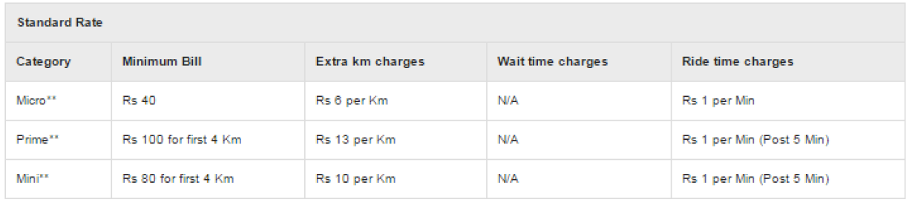

In addition to this, minimum fare of Micro is fixed at Rs. 50.

**Assumptions**

1. For all trips assume that every km journey will be completed in 4.5 minutes.

2. No toll to be assumed in all the trips.

3. No Taxes are applied for simplicity.

4. Multipliers are applied on final bill amount.

5. Cancellation charges cannot be waived off if the booking has been made.

6. Peak hours are from 6 pm to 12 am

7. If a customer pays through ola money, 60% of it goes to OLA and remaining goes to the driver.

8. Max speed within city limit is 60km/hr.

**Questions**

1. You have booked the MICRO vehicle. How much will it cost for 10 kms?

2. You have booked the MINI Vehicle. How much will it cost for 15 kms?

3. Calculate the following:

• Total Trips taken per Month,

• Total Trips taker per Hour,

4. Name the Driver with most distance travelled in last 3 months.

5. Name the Driver with time travelled in last 10 days.

6.List down the customers who has highest number of cancellation.

7.List the name of drivers who have crossed the speed limit in past 3 weeks. (Use the formula: Speed=Distance/time).

8.Which area do you think has the highest booking rate?

1)select

minimum_bill,(extra_km_chjarged)*10

from standard_rate where category='micro'

2)select (minbill)*(4)+13*(extra_km_charges) from standard_rate

where category='mini'

3)select count(trip) from date_table group by hour(date)

4)select drivername from driver where exists(select sum(distance) from ride_table)

5)select drivername from driver

where exists(select sum(hours_traveled) from travel

6.select customers from customer having max(cancel)

7.select drivername,(travel_distance/travelled_time) speed from driver

where datediff(ww,-3,getdate()))

8.select city from booking having max(no_of_booking)